Respawning a Character

This tutorial requires that the player has a controller set up. If not, create the controller script and set it up as follows:

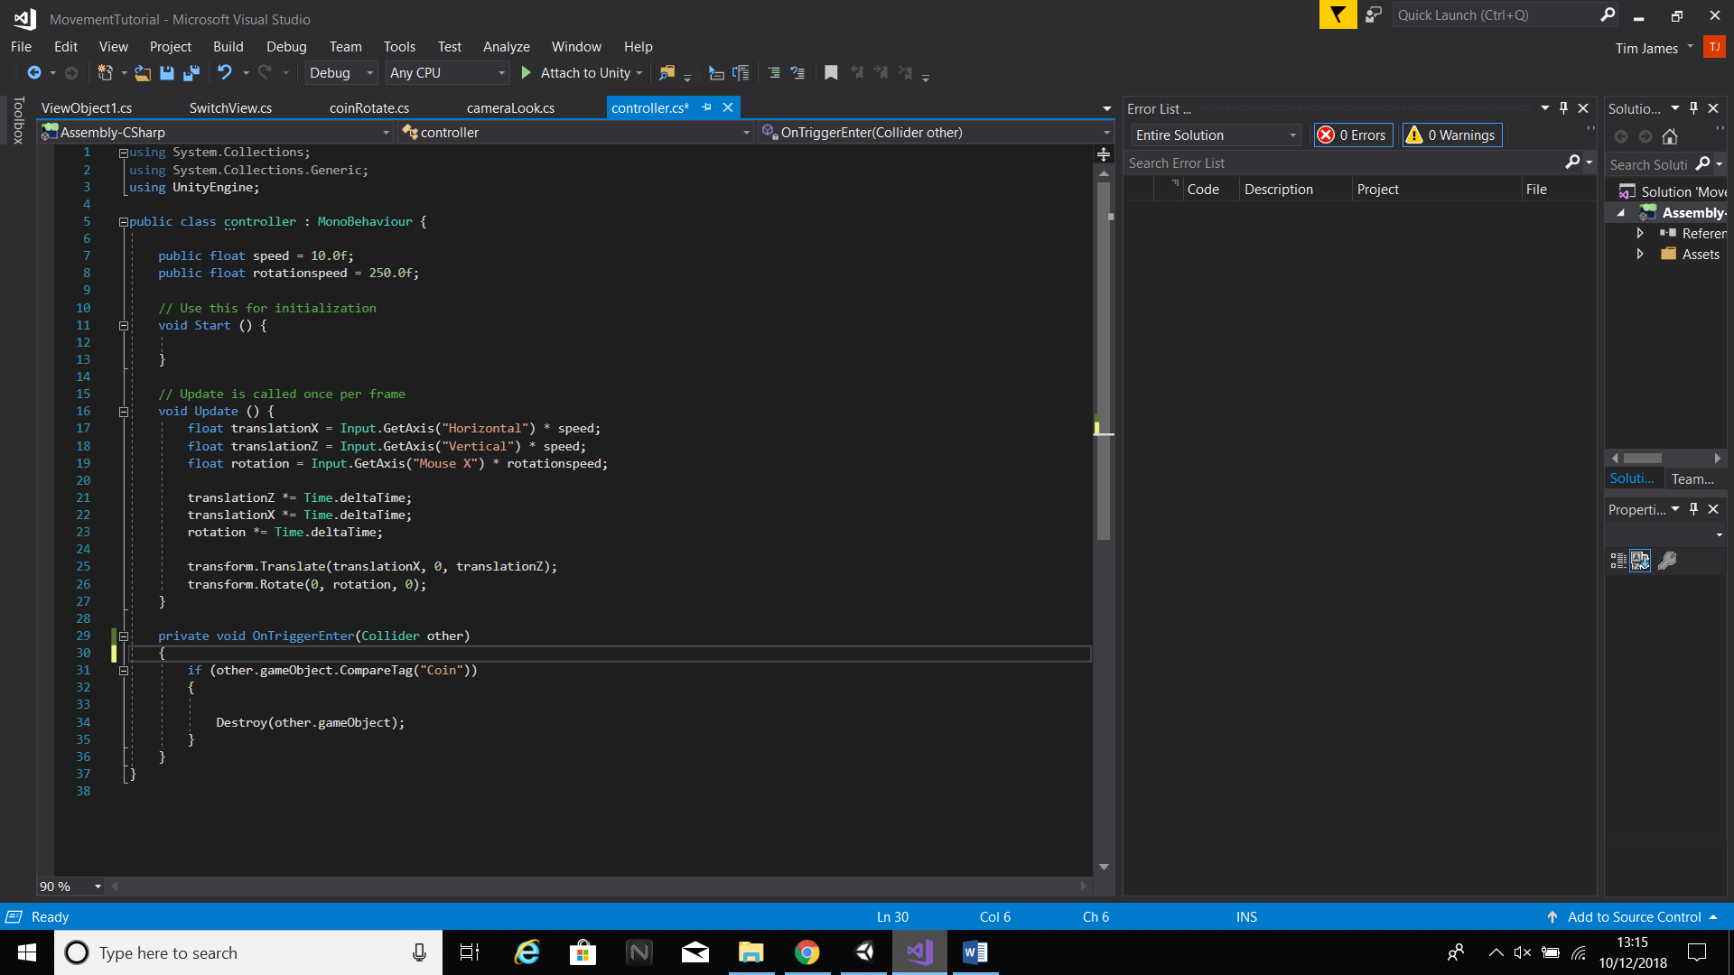

Make sure that the script is attached to an object; for the sake of the tutorial it can be any object, just ensure that the camera is parented to it.

This tutorial will go over how to script kill zones and respawn points. To start, set up a room with a pit in the middle which will function as the kill zone.

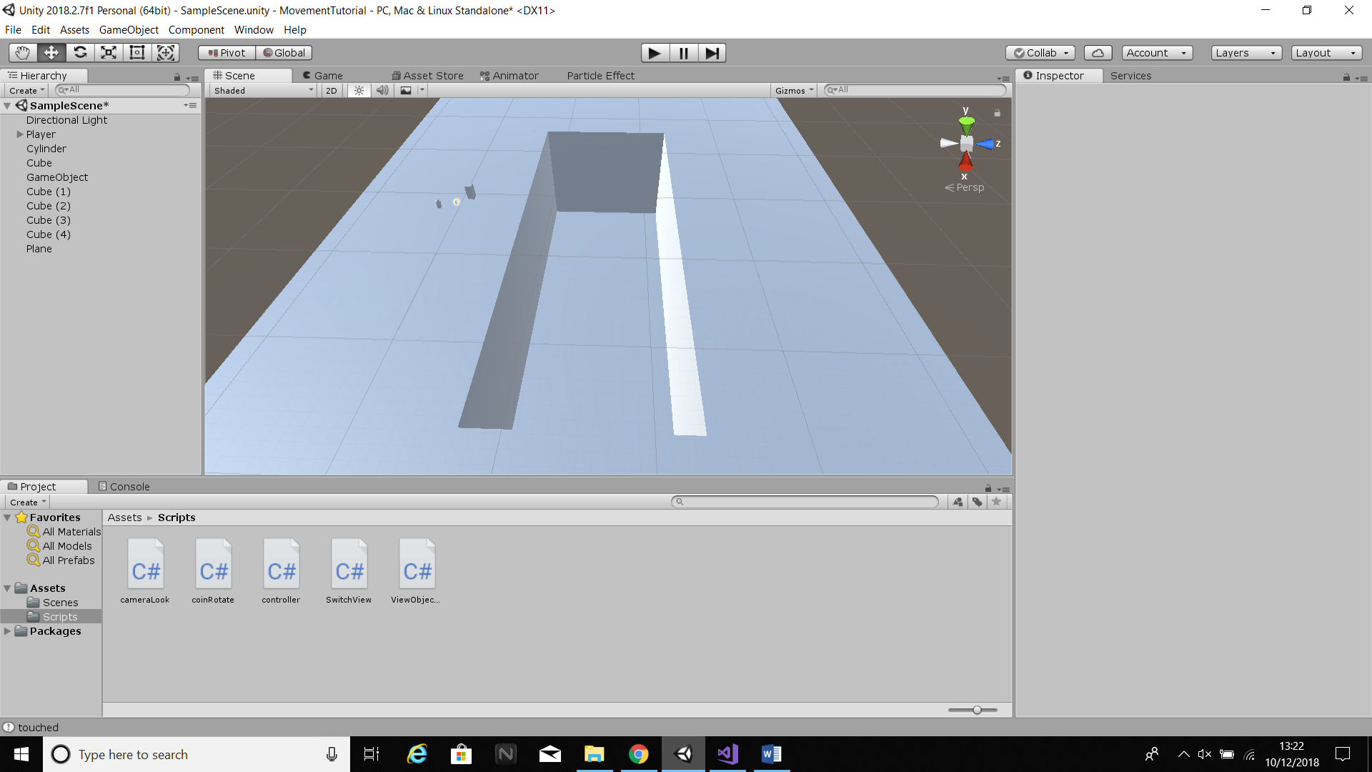

In the pit, create an object with a box collider and set the box collider to a trigger. This will be the kill zone. Then create an empty object beside the pit which will function as a respawn point.

Now create a script called “KillZone” and attach it to the kill zone. The first thing to do is set up the player and the respawn zone. To do this, use [SerializeField] for both.

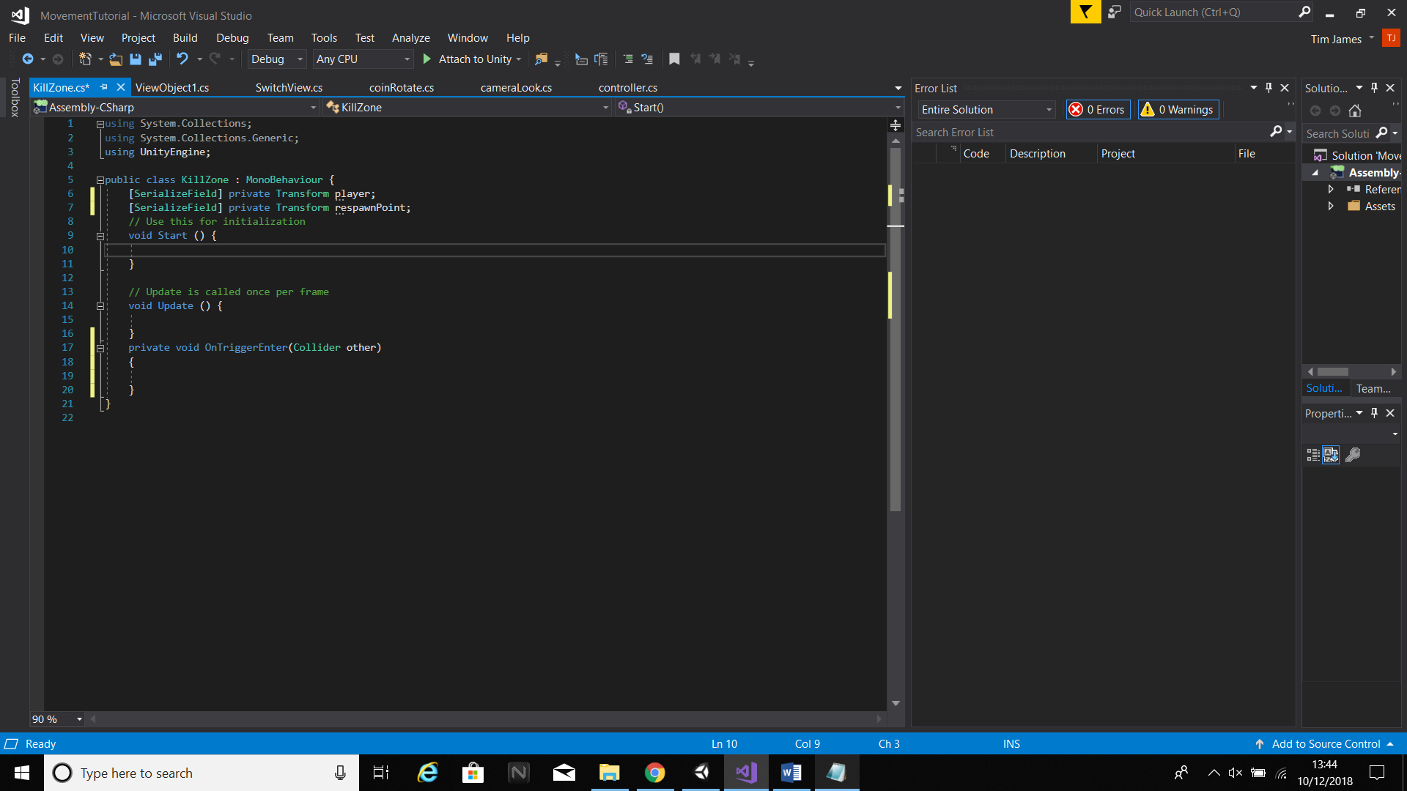

Now create an OnTriggerEnter void. In this void, set the player’s position to the respawn point.

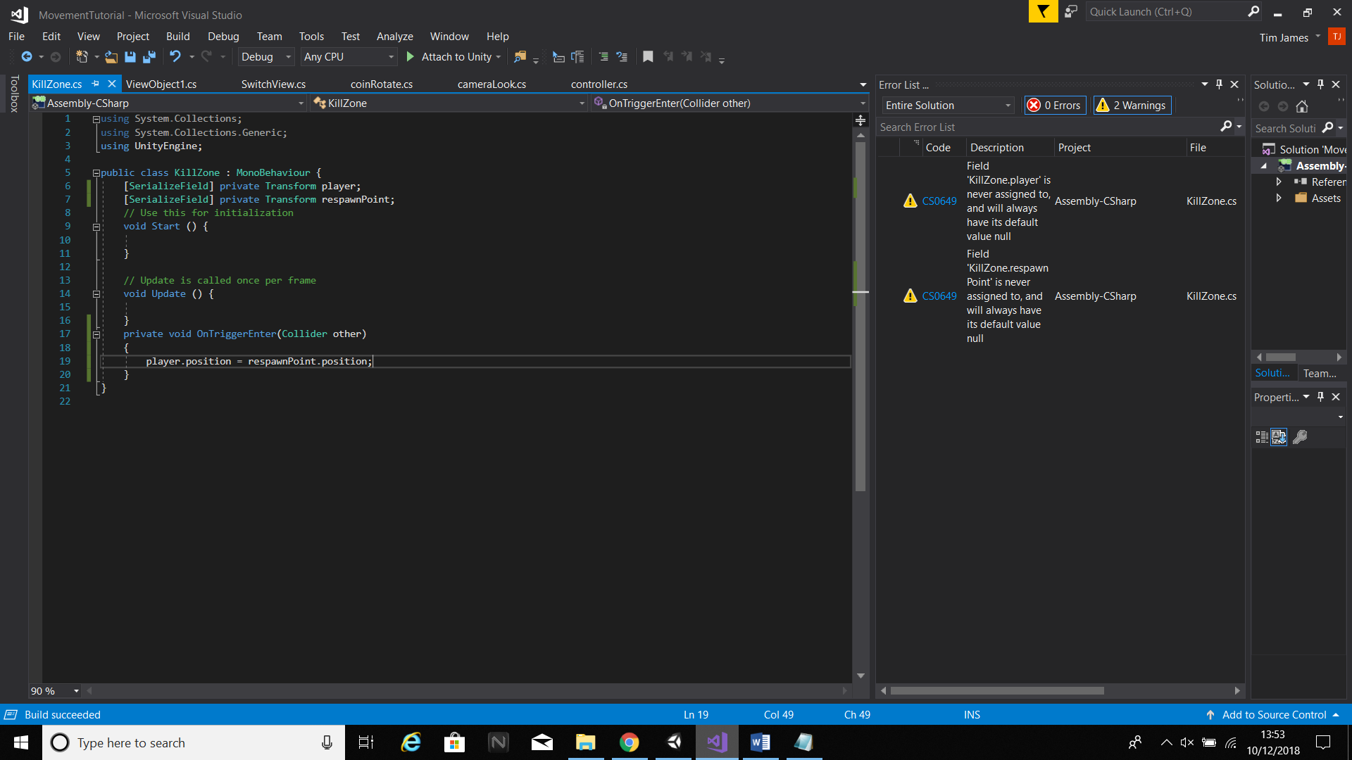

The last thing left to do is assign the transforms to the player and the respawn zone in the engine. Once this is done, the player will respawn at the co-ordinates of the respawn object whenever they fall into the pit.